**Autonomous Vehicle System Requirements Specification**

**1. Scope.**

* 1. **Identification.**

AVS – Automated Vehicle System

MF – Mounting Frame

WC – Wireless Communications

MC – Motor Control

NM – Navigation and Mazing

OD – Obstacle Detection

LS – Location via Pozyx

UI – User interface

CH – RC Chassis

OP – On-board power

On-board System Control Group – Name given to the group containing all of the on-board sub-systems required for the control of the AVS (WC, MC, NM, OD, LS)

* 1. **Overview.**

The Autonomous Vehicle System is a prototype vehicle that is intended to navigate through a course autonomously; from a start point to a given target location, and back again. The stakeholder has specified a starting point, with certain requirements, in the Project Brief. The system is to be based off some existing parts, while other parts will need to be acquired. Operation, verification and validation is to be undertaken by the AVS team (see Notes). The operating sites consist of the G04 project room and the Building 16 workshop, on the UNSW Canberra campus.

* 1. **Document overview.**

The purpose of this document is to provide requirements and specifications for the system so that a design phase can be implemented upon. This report also specifies verification and validation procedures to ensure an end product is realised. Sub-systems will use this report for traceability and justification for their own requirements and specifications. A context diagram was created to provide a visual understanding of the interfaces.

**2. Referenced documents.**

1. ZEIT4230 Electrical Engineering Design Practice Project Brief Version 1 Mar 18

**3. Requirements.**

**3.1 Required states and modes.**

|  |  |
| --- | --- |
| **Requirement ID:**  AVS-01 | **Requirement Statement**  The system shall have a barebones mode for initial testing |
| **Verification Method**  Testing | **Verification Description**  Wireless Communication testing, Arduino flashing, battery testing |
| **Traceability**  Top-level requirement | **Rationale/explanation** |
| **States/Modes applicability:**  Not used | |

|  |  |
| --- | --- |
| **Requirement ID:**  AVS-02 | **Requirement Statement**  The system shall have an operational mode for full functionality and testing |
| **Verification Method**  Testing | **Verification Description**  Operational testing and course validation |
| **Traceability**  Top-level requirement | **Rationale/explanation** |
| **States/Modes applicability:**  Not used | |

**3.2 Function and performance requirements.**

**3.2.1 Operational Requirements.**

|  |  |
| --- | --- |
| **Requirement ID:**  AVS-03 | **Requirement Statement**  The system shall accept a target position and be capable of autonomously navigating to this position. |
| **Verification Method**  Testing, Analysis | **Verification Description**  Operational test, Analysis of code and successful flash |
| **Traceability**  Top-level requirement | **Rationale/explanation** |
| **States/Modes applicability:**  Operational | |

|  |  |
| --- | --- |
| **Requirement ID:**  AVS-04 | **Requirement Statement**  The system shall return to the start position after arriving at the target position |
| **Verification Method**  Testing | **Verification Description**  Operational test |
| **Traceability**  AVS-03 | **Rationale/explanation**  Relies on existing target data |
| **States/Modes applicability:**  Operational | |

|  |  |
| --- | --- |
| **Requirement ID:**  AVS-05 | **Requirement Statement**  The system shall navigate autonomously as quickly as possible. |
| **Verification Method**  Testing, Analysis | **Verification Description**  Operational test, analysis of timer |
| **Traceability**  Top-level requirement | **Rationale/explanation** |
| **States/Modes applicability:**  Operational | |

|  |  |
| --- | --- |
| **Requirement ID:**  AVS-06 | **Requirement Statement**  The system shall avoid all obstacles on the grid. |
| **Verification Method**  Testing, Analysis | **Verification Description**  Operational test, analysis of timer |
| **Traceability**  Top-level requirement | **Rationale/explanation** |
| **States/Modes applicability:**  Operational | |

|  |  |
| --- | --- |
| **Requirement ID:**  AVS-07 | **Requirement Statement**  The system shall provide wireless telemetry data to a computer during operation, which entails current position, current heading, current velocity |
| **Verification Method**  Testing, Analysis | **Verification Description**  Operational test, analysis of received data on laptop |
| **Traceability**  AVS-03 | **Rationale/explanation**  This requirement is set by the stakeholder |
| **States/Modes applicability:**  Barebones, Operational | |

|  |  |
| --- | --- |
| **Requirement ID:**  AVS-08 | **Requirement Statement**  The system shall provide wireless obstacle location data to a computer during operation |
| **Verification Method**  Testing | **Verification Description**  Operational test |
| **Traceability**  AVS-03 | **Rationale/explanation**  This requirement is set by the stakeholder |
| **States/Modes applicability:**  Barebones, Operational | |
| **Requirement ID:**  AVS-09 | **Requirement Statement**  The system shall be battery powered by an on-board power system. |
| **Verification Method**  Testing | **Verification Description**  Operational test |
| **Traceability**  Top-level requirement | **Rationale/explanation**  This requirement is set by the stakeholder. Will allow the AVS to operate completely wirelessly. |
| **States/Modes applicability:**  Barebones, Operational | |

**3.2.2 Cornering Requirements**

|  |  |
| --- | --- |
| **Requirement ID:**  AVS-10 | **Requirement Statement**  The system shall corner within a 50cm grid space |
| **Verification Method**  Testing | **Verification Description**  Operational test |
| **Traceability**  AVS-06 | **Rationale/explanation**  This requirement is to avoid collision with obstacles within each grid space (Figure 2 Project Brief) |
| **States/Modes applicability:**  Operational | |

**3.2.3 Braking requirements**

|  |  |
| --- | --- |
| **Requirement ID:**  AVS-11 | **Requirement Statement**  The system shall brake within a small enough distance that avoids collision while being under the maximum sensor distance (to be verified in sensor testing) |
| **Verification Method**  Testing | **Verification Description**  Operational test, Sensor testing |
| **Traceability**  AVS-06 | **Rationale/explanation**  This requirement is to avoid collision with obstacles within each grid space (Figure 2 Project Brief) |
| **States/Modes applicability:**  Operational | |

**3.2.4 Speed related requirements**

See AVS-05.

**3.2.5 Battery efficiency requirements**

|  |  |
| --- | --- |
| **Requirement ID:**  AVS-12 | **Requirement Statement**  The system shall be powered long enough to complete the course twice |
| **Verification Method**  Testing | **Verification Description**  Operational test |
| **Traceability**  AVS-09 | **Rationale/explanation**  Allows time for a test run or backup attempt |
| **States/Modes applicability:**  Operational | |

**3.2.6 Range and endurance requirements**

See AVS-10.

**3.2.7 Starting requirements**

See AVS-03.

**3.2.8 Shut down requirements (normal)**

|  |  |
| --- | --- |
| **Requirement ID:**  AVS-13 | **Requirement Statement**  The system shall have a standard shut-down feature once the course is completed |
| **Verification Method**  Testing | **Verification Description**  Operational test |
| **Traceability**  AVS-09 | **Rationale/explanation**  Avoids inf looping or motor power drain |
| **States/Modes applicability:**  Operational | |

**3.2.9 Shut down requirements (emergency)**

|  |  |
| --- | --- |
| **Requirement ID:**  AVS-14 | **Requirement Statement**  The system shall have an emergency shut-down switch in case of extreme failure |
| **Verification Method**  Testing | **Verification Description**  Operational test |
| **Traceability**  Top-level requirement | **Rationale/explanation**  Safety requirement |
| **States/Modes applicability:**  Operational | |

**3.3 External interface requirements.**

**3.3.1 Interface identification and diagrams.**

The identifications for each sub-system is as follows:

MF – Mounting Frame

WC – Wireless Communications

MC – Motor Controller

NM – Navigation and Mazing

OD – Obstacle Detection

LS – Position and Location via Pozyx

UI – General User interface

CH – RC Chassis

OP – On-board power

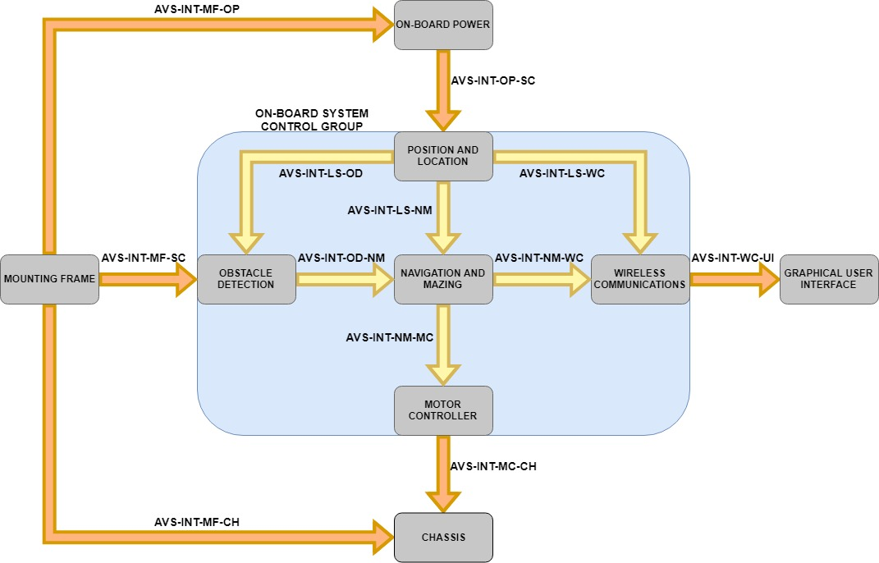

Figure 1: The interconnecting context diagram of the system.

**3.3.2 Mounting Frame and Chassis** **Interface (AVS-INT-MF-CH)**

|  |  |
| --- | --- |
| **Requirement ID:**  AVS-15 | **Requirement Statement**  The system shall have a 3D printed mounting frame that is compatible with the RC chassis supplied |
| **Verification Method**  Inspection | **Verification Description**  Inspect plans and printed material. Ensure fits securely with bolts. |
| **Traceability**  Top-level requirement | **Rationale/explanation**  This requirement is set by the stakeholder, and the parts must be fabricated |
| **States/Modes applicability:**  Not used | |

**3.3.3 Mounting Frame and On-board power system Interface (AVS-INT-MF-OP)**

|  |  |
| --- | --- |
| **Requirement ID:**  AVS-16 | **Requirement Statement**  The system shall have a 3D printed mounting frame that is compatible with the on-board power system. |
| **Verification Method**  Inspection | **Verification Description**  Inspect plans and printed material. Ensure fits securely with bolts. |
| **Traceability**  AVS-09 | **Rationale/explanation**  This requirement is set by the stakeholder, and the parts must be fabricated. Will allow the system to be battery operated and operate wirelessly |
| **States/Modes applicability:**  Not used | |

**3.3.4 Mounting Frame and On-board System Control Interface (AVS-INT-MF-SC)**

|  |  |
| --- | --- |
| **Requirement ID:**  AVS-17 | **Requirement Statement**  The system shall have a 3D printed mounting frame that is compatible with the on-board system control group. |
| **Verification Method**  Inspection | **Verification Description**  Inspect plans and printed material. Ensure fits securely with bolts. |
| **Traceability**  AVS-03 | **Rationale/explanation**  This requirement is set by the stakeholder, and the parts must be fabricated |
| **States/Modes applicability:**  Not used | |

**3.3.5 Wireless Communications Sub-System and Computer (laptop) (AVS-INT-WC-UI)**

|  |  |
| --- | --- |
| **Requirement ID:**  AVS-18 | **Requirement Statement**  The system shall have a computer graphical display of vehicle position and discovered obstacles, with speed and bearing data |
| **Verification Method**  Testing | **Verification Description**  Barebones test, Operational test |
| **Traceability**  AVS-07 | **Rationale/explanation**  This requirement is set by the stakeholder, and the parts must be acquired. Will allow users to gauge AVS operational performance in real time. |
| **States/Modes applicability:**  Barebones, Operational | |

**3.3.6 Motor Controller and Chassis Interface (AVS-INT-MC-CH)**

|  |  |
| --- | --- |
| **Requirement ID:**  AVS-19 | **Requirement Statement**  The system shall have a motor controller that drives the motor onboard the RC vehicle chassis |
| **Verification Method**  Testing | **Verification Description**  Operational test |
| **Traceability**  AVS-05 | **Rationale/explanation**  This requirement is set by the stakeholder, and the parts must be acquired |
| **States/Modes applicability:**  Operational | |

**3.3.7 Navigation and mazing, and Motor Controller Interface (AVS-INT-NM-MC)**

|  |  |
| --- | --- |
| **Requirement ID:**  AVS-20 | **Requirement Statement**  The system shall have a navigation algorithm that can instruct the motor controller to move in order to complete the course |
| **Verification Method**  Testing | **Verification Description**  Operational test |
| **Traceability**  AVS-05 | **Rationale/explanation**  This is required for the main system operational requirement |
| **States/Modes applicability:**  Operational | |

**3.3.8 Navigation and mazing, and Wireless Communications Interface (AVS-INT-NM-WC)**

|  |  |
| --- | --- |
| **Requirement ID:**  AVS-21 | **Requirement Statement**  The system shall communicate the navigation planned route, including object location through the Wireless Communications System. |
| **Verification Method**  Testing | **Verification Description**  Operational test |
| **Traceability**  AVS-07 | **Rationale/explanation**  This is required for the main system operational requirement |
| **States/Modes applicability:**  Operational | |

**3.3.9 Obstacle detection and Navigation and Mazing Interface (AVS-INT-OD-NM)**

|  |  |
| --- | --- |
| **Requirement ID:**  AVS-22 | **Requirement Statement**  The system shall have sensors and algorithms in place to detect and record obstacle locations which will be used by the Navigation and Mazing System for route planning. |
| **Verification Method**  Testing | **Verification Description**  Operational test |
| **Traceability**  AVS-05, AVS-06 | **Rationale/explanation**  This is required for the main system operational requirement |
| **States/Modes applicability:**  Operational | |

**3.3.10 Position and location detection (Pozyx) Interfaces (AVS-INT-LS-OD, AVS-INT-LS-NM, AVS-INT-LS-WC)**

|  |  |
| --- | --- |
| **Requirement ID:**  AVS-23 | **Requirement Statement**  The system shall have a constant update of spatial data for use by the various sub-systems. |
| **Verification Method**  Testing | **Verification Description**  Operational test |
| **Traceability**  AVS-03, AVS-05 | **Rationale/explanation**  This requirement is set by the stakeholder, and uses the supplied Pozyx circuit card. Will allow the AVS to navigate the grid, store object locations and provide navigation details to the GUI. |
| **States/Modes applicability:**  Operational | |

**3.3.11 On-board Power and On-board System Control Group Interface (AVS-INT-OP-SC)**

|  |  |
| --- | --- |
| **Requirement ID:**  AVS-24 | **Requirement Statement**  The system shall provide on-board power to the sub-systems contained within the on-board system control group. |
| **Verification Method**  Testing | **Verification Description**  Barebones test, Operational test |
| **Traceability**  AVS-09 | **Rationale/explanation**  This requirement is set by the stakeholder. Will allow the AVS to operate completely wirelessly. |
| **States/Modes applicability:**  Barebones, Operational | |

**3.4 Safety requirements.**

See AVS-12.

**3.5 Security requirements.**

|  |  |
| --- | --- |
| **Requirement ID:**  AVS-25 | **Requirement Statement**  The system shall have a basic security plan to avoid hacking or interference |
| **Verification Method**  Analysis | **Verification Description**  Analyse system for any insecurities |
| **Traceability**  Top-level requirement | **Rationale/explanation**  Change default passwords, keep equipment secure |
| **States/Modes applicability:**  Not used | |

**3.6 System environment requirements.**

|  |  |
| --- | --- |
| **Requirement ID:**  AVS-26 | **Requirement Statement**  The system shall avoid collisions with obstacles during autonomous navigation of a 5x5 m course |
| **Verification Method**  Testing | **Verification Description**  Operational test |
| **Traceability**  AVS-06 | **Rationale/explanation**  Environment conditions will not be fully known until finish date |
| **States/Modes applicability:**  Operational | |

|  |  |
| --- | --- |
| **Requirement ID:**  AVS-27 | **Requirement Statement**  The system shall be stored and operated out of moisture and excessive heat conditions |
| **Verification Method** | **Verification Description**  Not used |
| **Traceability**  Top-level requirement | **Rationale/explanation**  Environment essential for electronics |
| **States/Modes applicability:**  Barebones, Operational | |

**3.7 System quality factors.**

|  |  |
| --- | --- |
| **Requirement ID:**  AVS-28 | **Requirement Statement**  The system shall have a mean time to failure of greater than 20 mins |
| **Verification Method**  Testing | **Verification Description**  Operational test |
| **Traceability**  AVS-05 | **Rationale/explanation**  This should be tested after the functional requirements are met |
| **States/Modes applicability:**  Operational | |

**3.8 Budget requirements.**

|  |  |
| --- | --- |
| **Requirement ID:**  AVS-29 | **Requirement Statement**  The system shall have a budget of $150 |
| **Verification Method**  Inspection | **Verification Description**  Get quotes from two different large Australian electronic suppliers |
| **Traceability**  Top-level requirement | **Rationale/explanation**  This requirement is set by the stakeholder |
| **States/Modes applicability:**  Not used | |

**3.9 Design and construction constraints.**

|  |  |
| --- | --- |
| **Requirement ID:**  AVS-30 | **Requirement Statement**  The system shall use the components supplied (Table 1 Project Brief). These are as follows: Arduino Uno, 7.4V 850mAh battery, 9V 400mAh battery, Pozyx Tag, Ultrasonic range sensors x3, Motor speed, controller (needs acquisition), Wireless transmitter (needs acquisition) |
| **Verification Method**  Inspection | **Verification Description**  Conduct system inspection |
| **Traceability**  Top-level requirement | **Rationale/explanation**  This requirement is set by the stakeholder |
| **States/Modes applicability:**  Not used | |

|  |  |
| --- | --- |
| **Requirement ID:**  AVS-31 | **Requirement Statement**  The system shall operate on no more than 32Kb at any one time. |
| **Verification Method**  Inspection | **Verification Description**  Conduct system inspection |
| **Traceability**  AVS-30 | **Rationale/explanation**  The Arduino Uno has a memory capacity of 32Kb and hence all on-board processing must take place in the given space. |
| **States/Modes applicability:**  Not used | |

**3.10- Personnel-related requirements**.

|  |  |
| --- | --- |
| **Requirement ID:**  AVS-32 | **Requirement Statement**  The system shall have modular and efficient coding |
| **Verification Method**  Analysis | **Verification Description**  Perform flash |
| **Traceability**  AVS-31 | **Rationale/explanation**  Arduino Uno is restrictive on data storage, will allow the |
| **States/Modes applicability:**  Not used | |

**3.13 Other requirements.**

Not used.

**6. Notes.**

AVS Team members:

MF – Mounting Frame Luke Armstrong

WC – Wireless Communications Greg Hoffmann

MC – Motor Control Clinton Kerr

NM – Navigation and Mazing Brady Walker

OD – Obstacle Detection Alexander Gee

LS – Location via Pozyx Luke Armstrong

UI – User interface Ryan Gough

OP – On-board power As required

CH – RC Chassis As required

Testing methods:

Inspection Visual identification of item integrity or/and existence

Analysis Confirm code integrity, verify/upload of Arduino, sensor data, course time efficiency, battery efficiency

Testing Operational testing of sub-systems or systems with power applied

Modes of system:

Barebones Can be one sub-system being tested independently or with another sub-system to validate working status

Operational The system is complete or mostly complete, if all sub-systems are integrated

**A. Appendix.**